

1)

Select SUM(extcost),SUM(Quantity),calmonth, addrcatcode1 from inventory_fact,cust_vendor_dim,date_dim where date_dim.DateKey=inventory_fact.datekey

and cust_vendor_dim.custvendorkey=inventory_fact.custvendorkey and TransTypeKey=5 and date_dim.calyear=2011 group by cube(date_dim.calmonth,cust_vendor_dim.addrcatcode1)

order by calmonth, addrcatcode1;

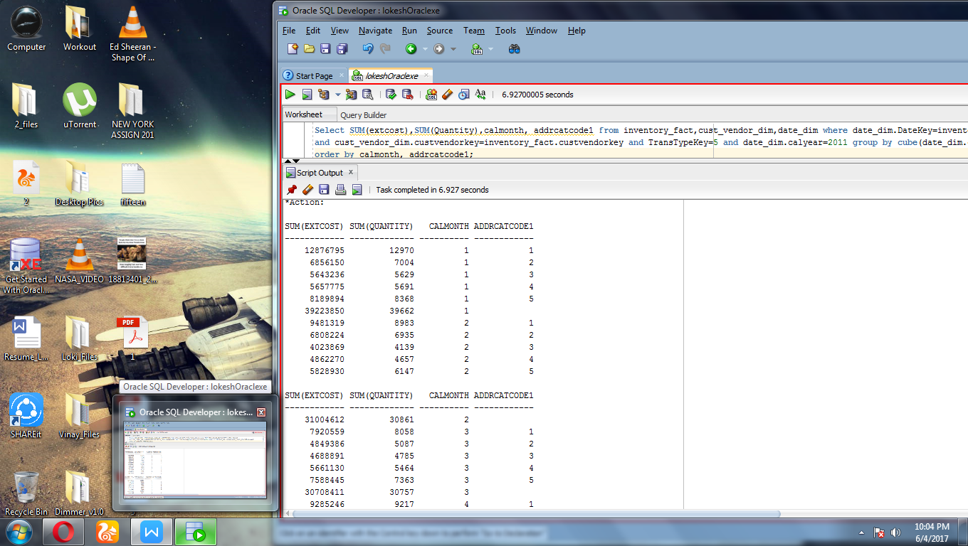

2)

Select SUM(extcost),count(*) as NoOfTransactions,calquarter,zip,name from inventory_fact,cust_vendor_dim,date_dim where date_dim.DateKey=inventory_fact.datekey

and cust_vendor_dim.custvendorkey=inventory_fact.custvendorkey and TransTypeKey=5 and date_dim.calyear=2011 or date_dim.calyear=2012 group by

Grouping sets((calquarter,zip,name),(calquarter,zip),(calquarter,name),(zip,name),zip,name,calquarter,())

order by zip,name,calquarter;

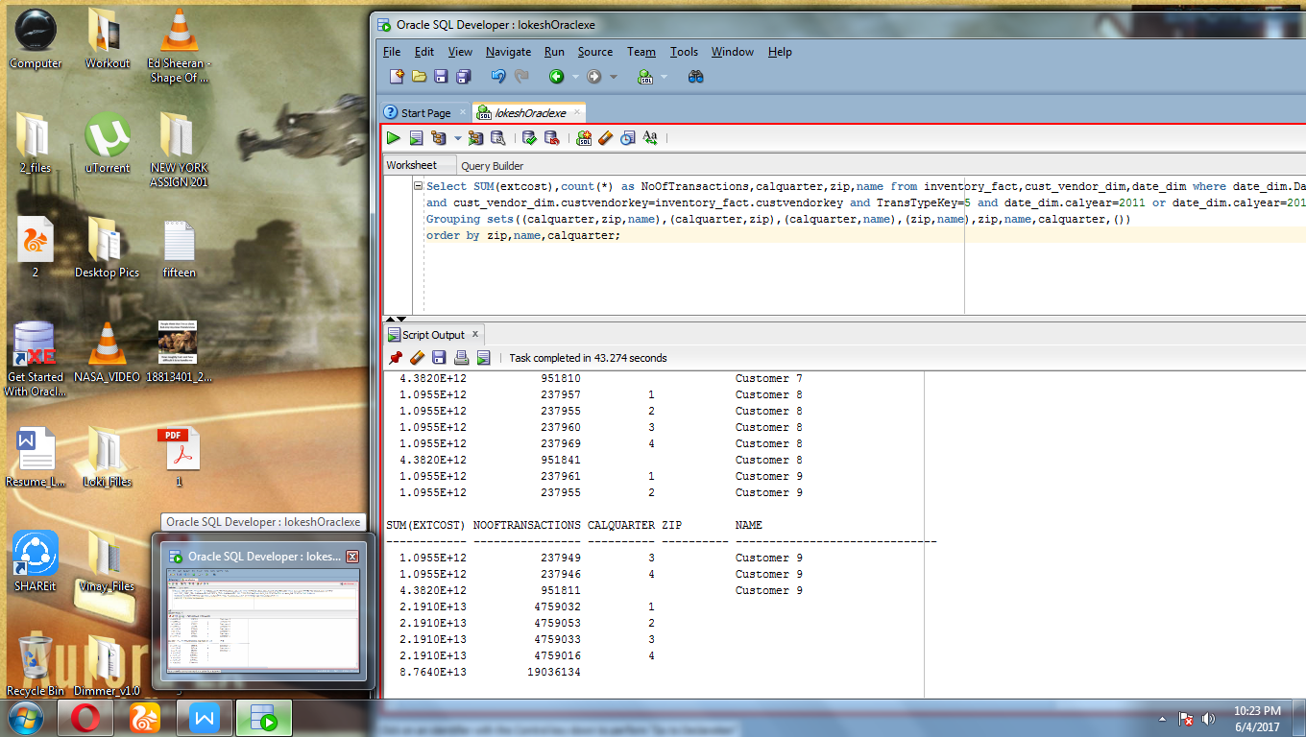

3)

Select SUM(extcost),SUM(Quantity),companyname,bpname from inventory_fact,branch_plant_dim,company_dim

where company_dim.CompanyKey=branch_plant_dim.Companykey

and branch_plant_dim.branchplantkey=inventory_fact.branchplantkey and TransTypeKey=2 group by ROLLUP(companyname,bpname)

order by companyname,bpname;

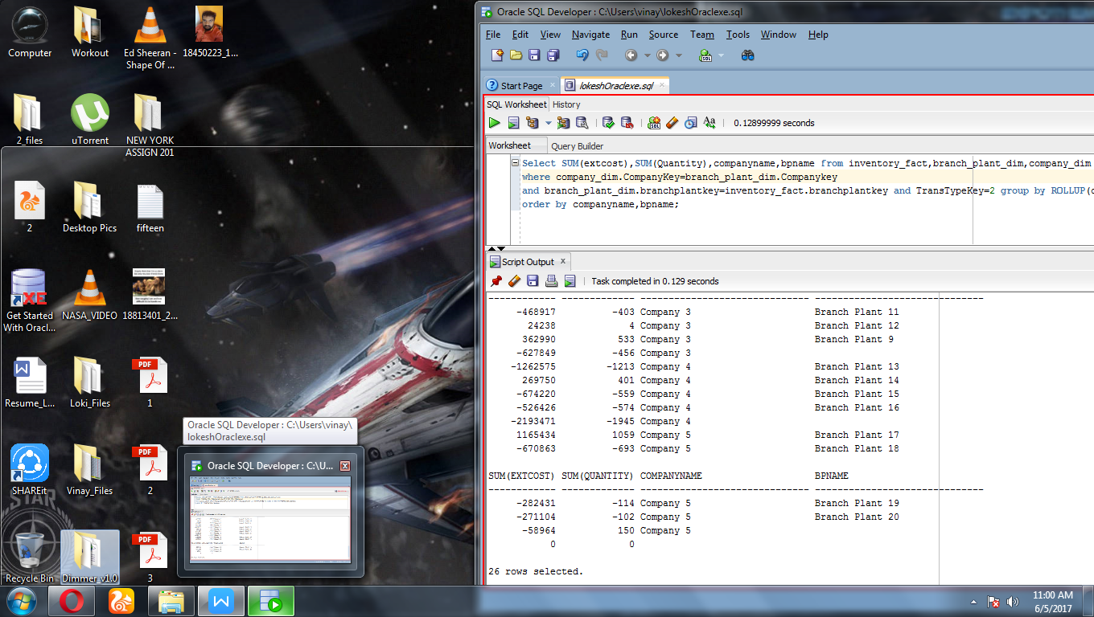

4)

Select SUM(extcost),count(*) as NoOfTransactions,transdescription,companyname,bpname from inventory_fact,branch_plant_dim,company_dim,trans_type_dim where company_dim.CompanyKey=branch_plant_dim.Companykey

and branch_plant_dim.branchplantkey=inventory_fact.branchplantkey and inventory_fact.transtypekey=trans_type_dim.transtypekey group by GROUPING SETS ((transdescription,companyname,bpname), (transdescription, companyname), transdescription, ()) order by companyname,bpname,transdescription;

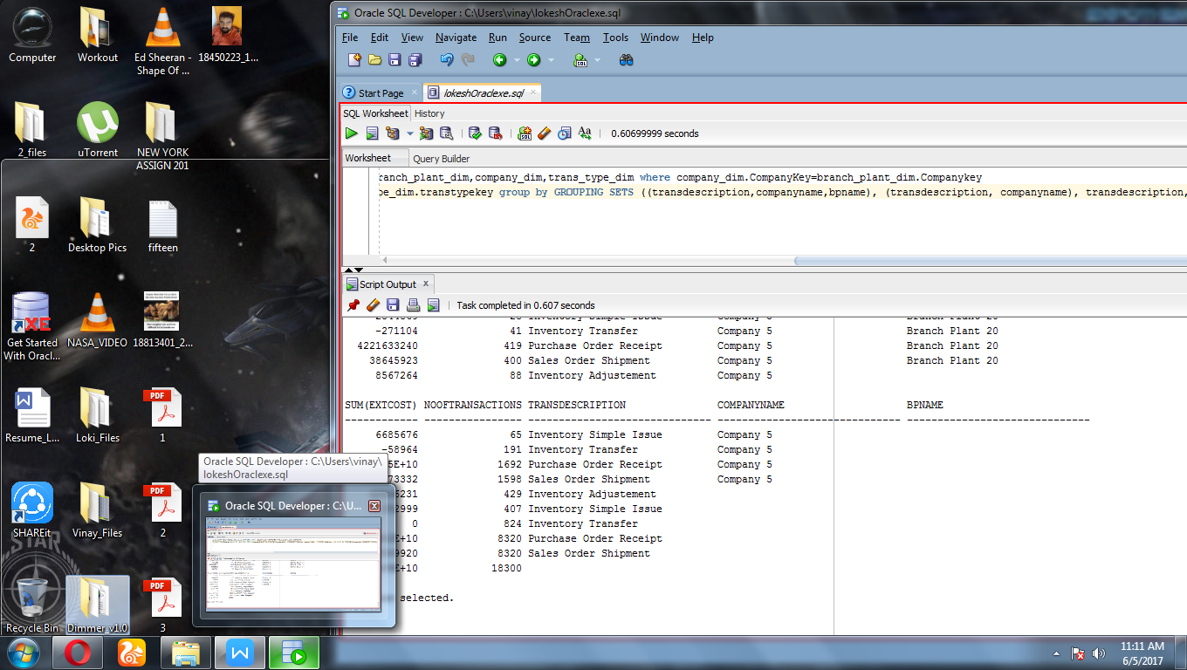

5)

Select SUM(extcost),count(*) as NoOfTransactions,calyear,calquarter,name from inventory_fact,cust_vendor_dim,date_dim where date_dim.DateKey=inventory_fact.datekey

and cust_vendor_dim.custvendorkey=inventory_fact.custvendorkey and TransTypeKey=5 and date_dim.calyear=2011 or date_dim.calyear=2012 group by name,

Rollup(calyear,calquarter) order by name,calyear,calquarter;

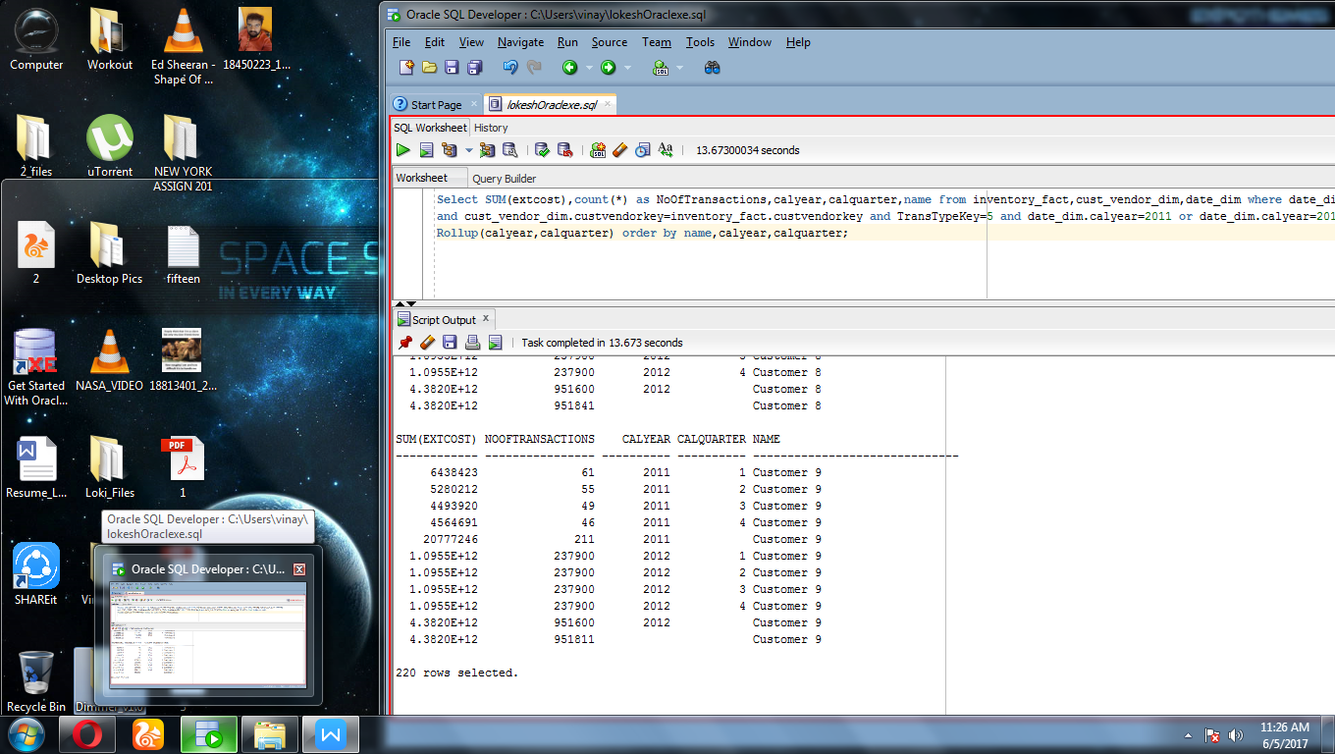

6)

Select SUM(extcost),SUM(Quantity),calmonth, addrcatcode1 from inventory_fact,cust_vendor_dim,date_dim where date_dim.DateKey=inventory_fact.datekey

and cust_vendor_dim.custvendorkey=inventory_fact.custvendorkey and TransTypeKey=5 and date_dim.calyear=2011 group by calmonth,addrcatcode1

UNION

Select SUM(extcost),SUM(Quantity),calmonth, NULL from inventory_fact,cust_vendor_dim,date_dim where date_dim.DateKey=inventory_fact.datekey

and cust_vendor_dim.custvendorkey=inventory_fact.custvendorkey and TransTypeKey=5 and date_dim.calyear=2011 group by calmonth

UNION

Select SUM(extcost),SUM(Quantity),NULL, addrcatcode1 from inventory_fact,cust_vendor_dim,date_dim where date_dim.DateKey=inventory_fact.datekey

and cust_vendor_dim.custvendorkey=inventory_fact.custvendorkey and TransTypeKey=5 and date_dim.calyear=2011 group by addrcatcode1

UNION

Select SUM(extcost),SUM(Quantity),NULL, NULL from inventory_fact,cust_vendor_dim,date_dim where date_dim.DateKey=inventory_fact.datekey

and cust_vendor_dim.custvendorkey=inventory_fact.custvendorkey and TransTypeKey=5 and date_dim.calyear=2011

ORDER BY 1,2;

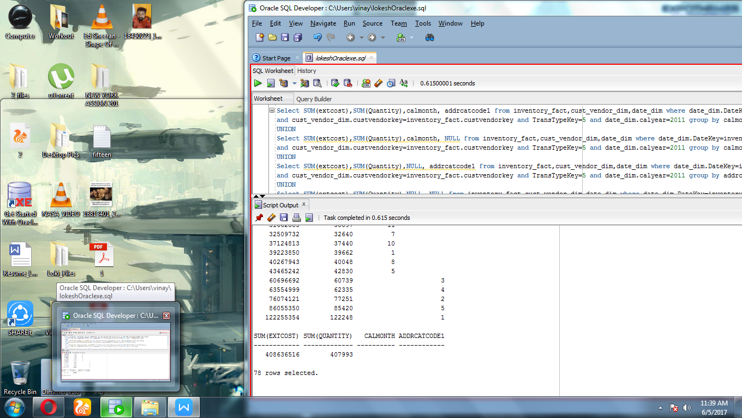

7)

Select SUM(extcost),SUM(Quantity),companyname,bpname from inventory_fact,branch_plant_dim,company_dim

where company_dim.CompanyKey=branch_plant_dim.Companykey

and branch_plant_dim.branchplantkey=inventory_fact.branchplantkey and TransTypeKey=2 group by companyname,bpname

UNION

Select SUM(extcost),SUM(Quantity),companyname,NULL from inventory_fact,branch_plant_dim,company_dim

where company_dim.CompanyKey=branch_plant_dim.Companykey

and branch_plant_dim.branchplantkey=inventory_fact.branchplantkey and TransTypeKey=2 group by companyname

UNION

Select SUM(extcost),SUM(Quantity),NULL,NULL from inventory_fact,branch_plant_dim,company_dim

where company_dim.CompanyKey=branch_plant_dim.Companykey

and branch_plant_dim.branchplantkey=inventory_fact.branchplantkey and TransTypeKey=2

ORDER BY 1,2;

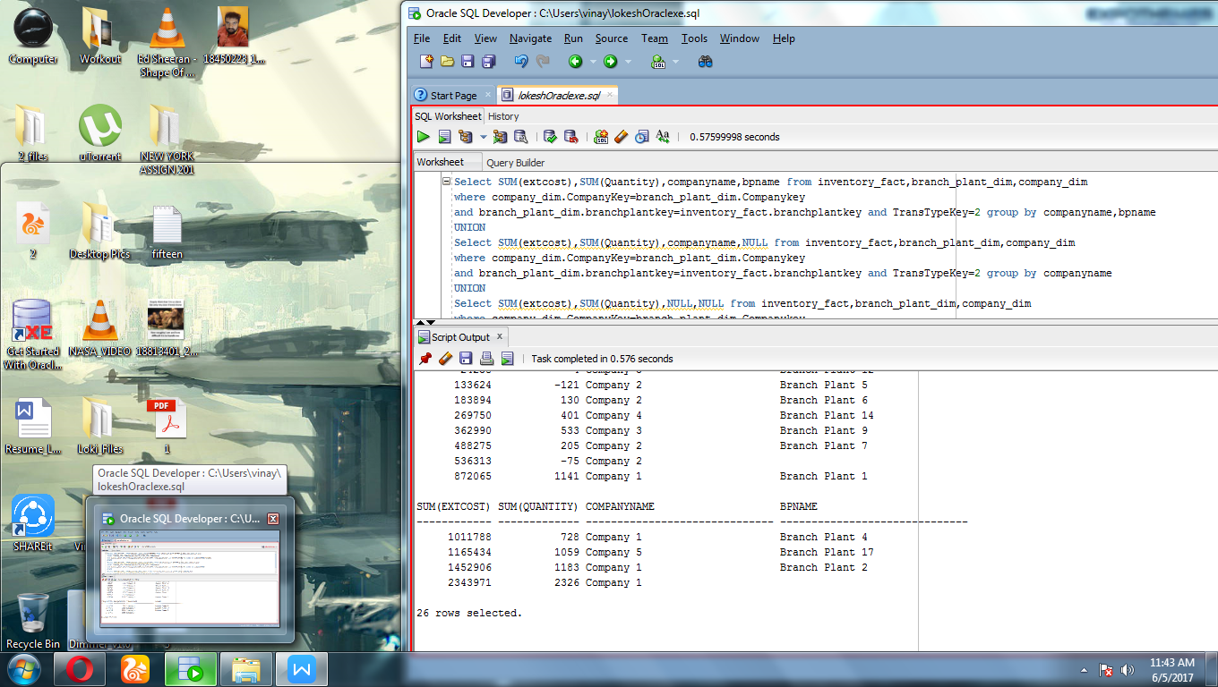

8)

Select SUM(extcost),count(*) as NoOfTransactions,calyear,calquarter,name from inventory_fact,cust_vendor_dim,date_dim where date_dim.DateKey=inventory_fact.datekey

and cust_vendor_dim.custvendorkey=inventory_fact.custvendorkey and TransTypeKey=5 and date_dim.calyear=2011 or date_dim.calyear=2012 group by

Rollup(name,(calyear,calquarter)) order by name,calyear,calquarter;

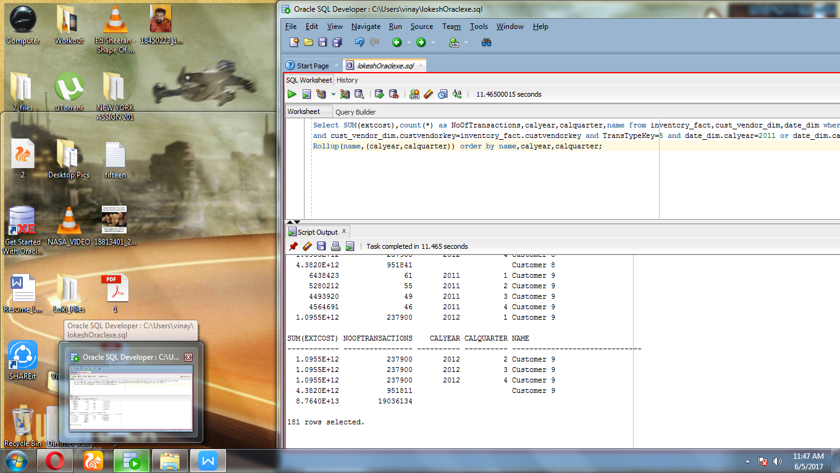

9)

Select SUM(extcost),SUM(Quantity),calmonth, addrcatcode1,GROUPING_ID(calmonth,addrcatcode1) AS Group_Level from inventory_fact,cust_vendor_dim,date_dim where date_dim.DateKey=inventory_fact.datekey

and cust_vendor_dim.custvendorkey=inventory_fact.custvendorkey and TransTypeKey=5 and date_dim.calyear=2011 group by cube(calmonth,addrcatcode1)

order by calmonth, addrcatcode1;

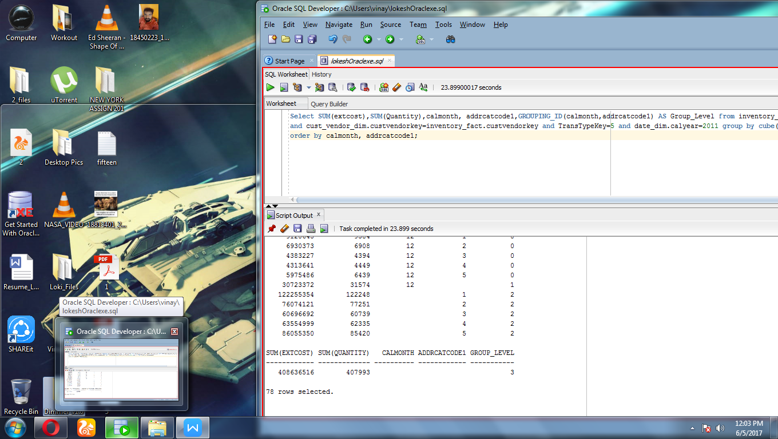

10)

Select SUM(extcost),count(*) as NoOfTransactions,calyear,calquarter,name from inventory_fact,cust_vendor_dim,date_dim where date_dim.DateKey=inventory_fact.datekey

and cust_vendor_dim.custvendorkey=inventory_fact.custvendorkey and TransTypeKey=5 and date_dim.calyear=2011 or date_dim.calyear=2012 group by GROUPING SETS(name, ROLLUP(calyear, calquarter)) order by name,calyear,calquarter;

